Introduction Html ;

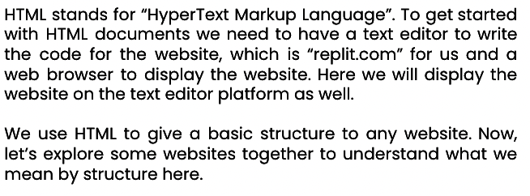

Html Flow ;

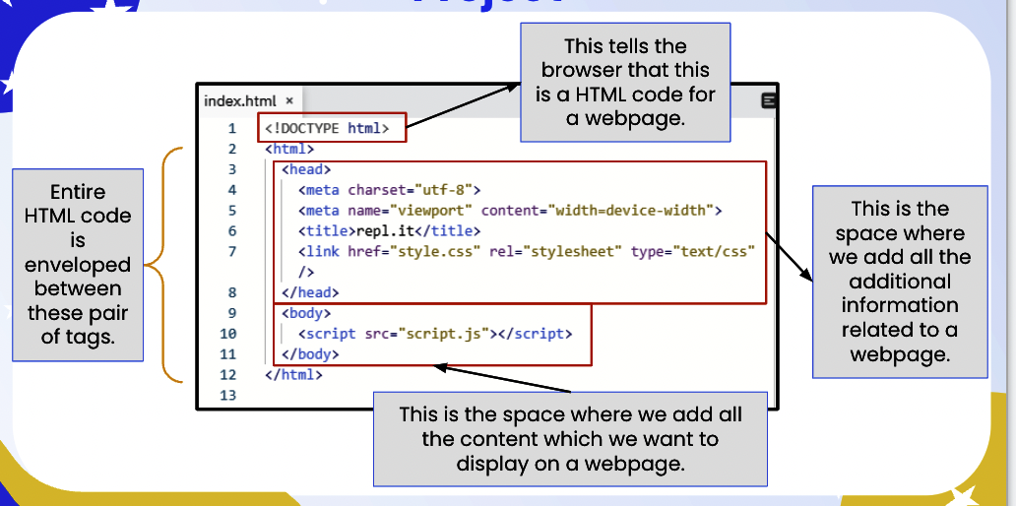

Difference div and section :

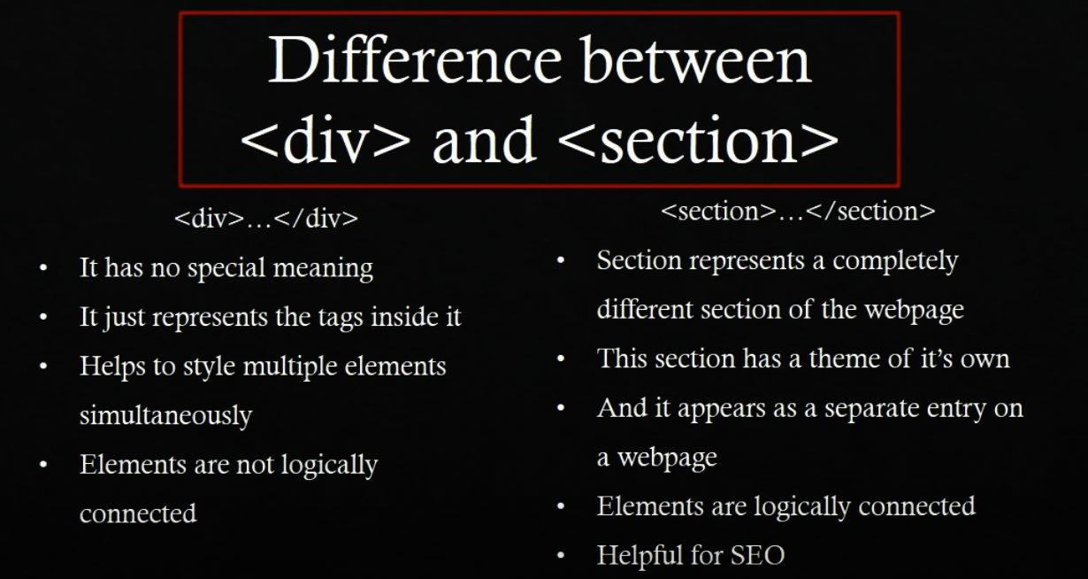

Several source to learn more :

1. <https://html5doctor.com/element-index/> ( official website )
2. <http://diveintohtml5.info/> ( another article )
3. <https://www.w3schools.com/html/default.asp> ( tutorial for tag on html, css and js )